The Great Gatsby – Chapter # 9 Assignment Name:
- Why couldn’t Nick get anyone to come to Gatsby’s funeral? Record 3 excuses given by “friends” of Gatsby.
- Who is Henry C. Gatz? Use quotes to describe his character.
- What is the significance of the old book? Where did it come from? What does it tell Nick and the reader about Gatsby?
- What happens between Nick and Jordan Baker? What is Jordan’s response?
- What does nick say about Daisy and Tom? Identify the quote and share your thoughts on Nick referring to both characters and their actions as being “careless people”.
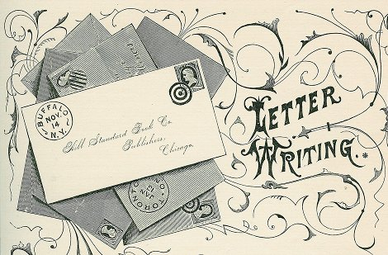
- After reading the end of this novel, what are your views on Daisy and Tom, and Daisy and Gatsby? Have they changed? How? Why? Use quotes from Chapter # 9 to support your answer.
Creative Writing Assignment:
You are to write a formal letter, given the character behaviors and events that have taken place in the novel. This should be 1 page typed double spaced. Font size 13, font style is up to you.

Please select one of the following options for your assignment:
- Write the letter that Daisy received on her wedding day from Jay Gatsby, upon his return from the war.
- Write a letter to Jay Gatsby from Daisy, following the events of Myrtle dying and Gatsby waiting in her yard until early morning.
- Write a letter from Tom to Daisy, a confessional apology, as he hopes to maintain their marriage, following the events that took place.
- Write a letter from Nick to the character of your choice, this letter should be following/referencing the events that took place. Who, why and what is up to you.

