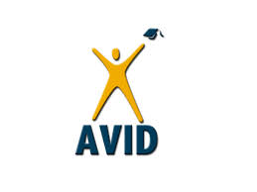
AVID CONTRACT FOR SUCCESS
Name of student: Today’s date:
Avid is a program which prepares students for post-secondary eligibility
Student Goals:
- Academic success in my high school course work
- Successful completion of all tasks/requirements/assignments in my classes
- Preparation for post-secondary
Student Responsibilities:
- Maintain enrolment in rigorous courses required to meet my goals
- Maintain successful passing grades in all of my classes
- Attend all classes regularly and on time
- Maintain a respectful attitude towards my school work, myself, my teachers and my peers
- Maintain an engaged attitude while in class, completing tasks and working with others
- Maintain my AVID binder with assignments, logs and daily Cornell notes in all classes
- Complete an hour of homework/study each night and submit homework assignments on time
- I will participate in extracurricular activities and community service
- I will be an active learner and implement my AVID strategies on a daily basis
- I will arrive to Tutorials with my TRF Pre-Work completed, textbooks ready, and I will use strong critical thinking and inquiry skills to create a greater understanding about my point of confusion
- I will aspire to develop/maintain a growth mindset and work to be the best version of myself
Student Signature:
Support Agreement:
We agree to support the efforts of this student in meeting the goals outlined above.

______________________________
Parent Signature AVID teacher signature

______________________________
AVID Coordinator Signature AVID Counsellor signature

